Organising categories and phrases on the Therapy Box website

It’s much easier to manage your Predictable customisations within your account on their Therapy Box website. On page 17 of the Predictable 6 manual it does say you can edit and delete categories on the iPad, but in practice it just doesn’t seem to work.

In other respects, the manual is quite useful though:

https://therapy-box.co.uk/docs/PA5English_user_guide.pdf

To access the Therapy Box website, you do need to access it on a computer and you have to sign on with the username and password you used when you set up the Predictable app on the iPad. (Hopefully you can remember!)

I have a Mac computer and, for some reason, the Therapy Box website doesn’t work happily on the default Safari web browser. But it does work well using the Google Chrome browser. If you have a PC (rather than a Mac) then I imagine that Therapy Box will play nicely with Chrome there too. I don’t know about other PC web browsers.

Any changes you make to categories, phrases etc on the Therapy Box website will immediately and automatically feed through to the app on your iPad.

So, using the Chrome browser, go to the following web page:

https://therapy-box.co.uk

You’ll open a page that looks like this. Click where it says Sign in and enter your credentials:

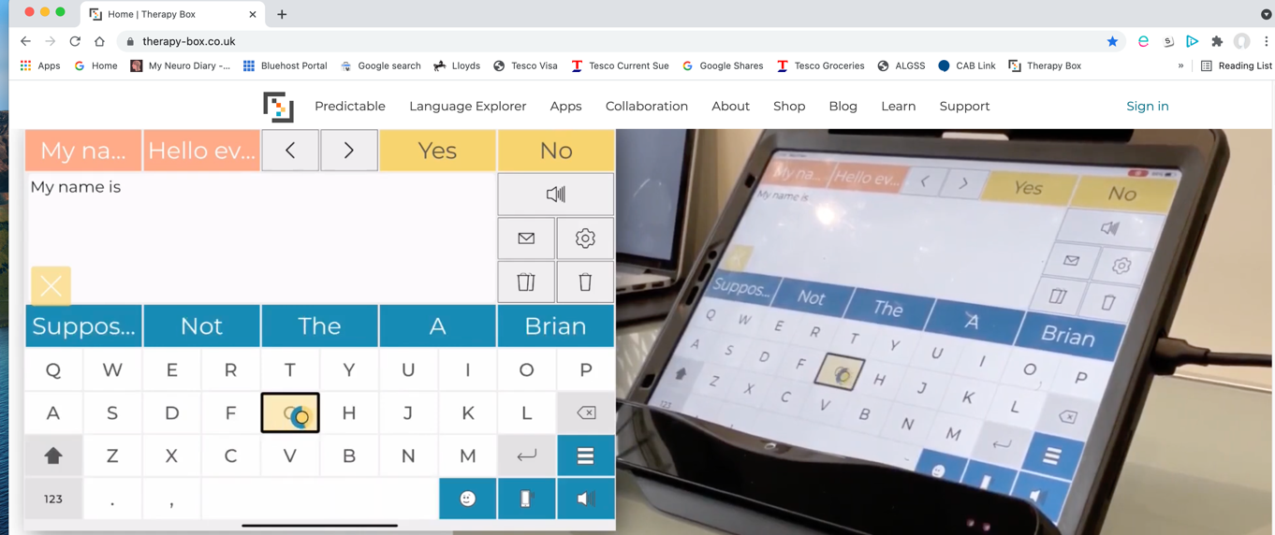

Managing Categories

On the next page, click on PHRASE BANK at the top of the screen

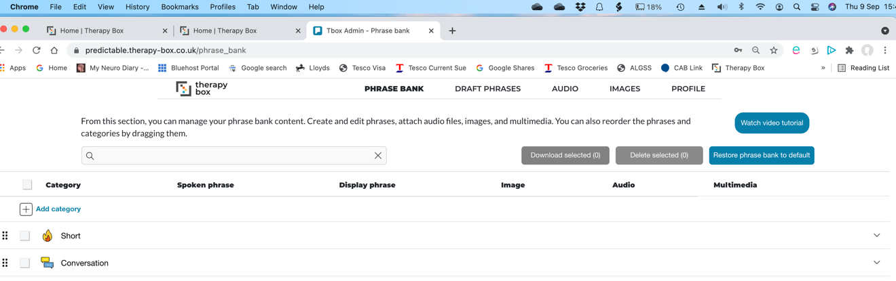

You’ll see a list of the categories as they appear on your iPad.

You can change the order of the categories by simply clicking and dragging and any changes you make will instantly feed through to your iPad. In this example I’ve clicked on my Conversation category (a category I made up) and I’m dragging it to appear further down the list:

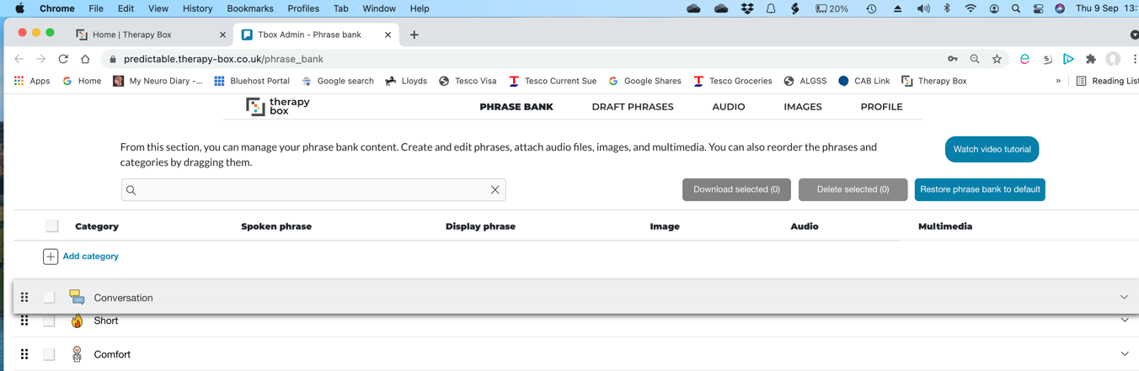

You can create a new category by clicking on Add category

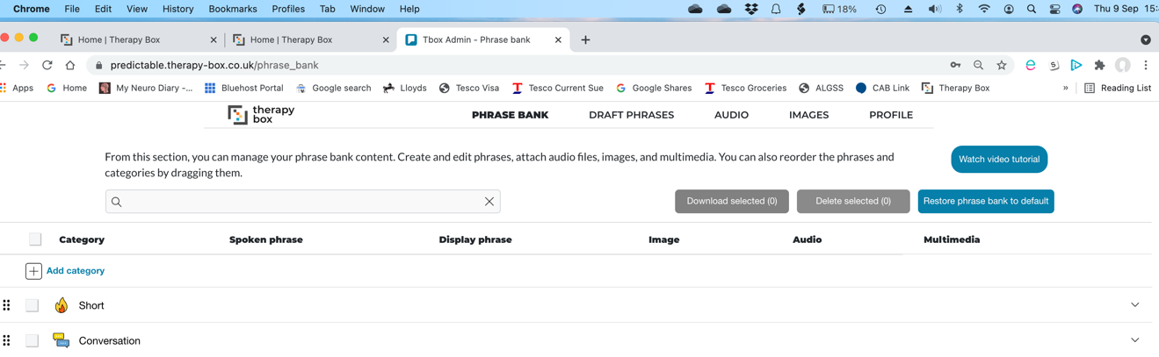

Then type in your name for the Category by over typing where it says New Category

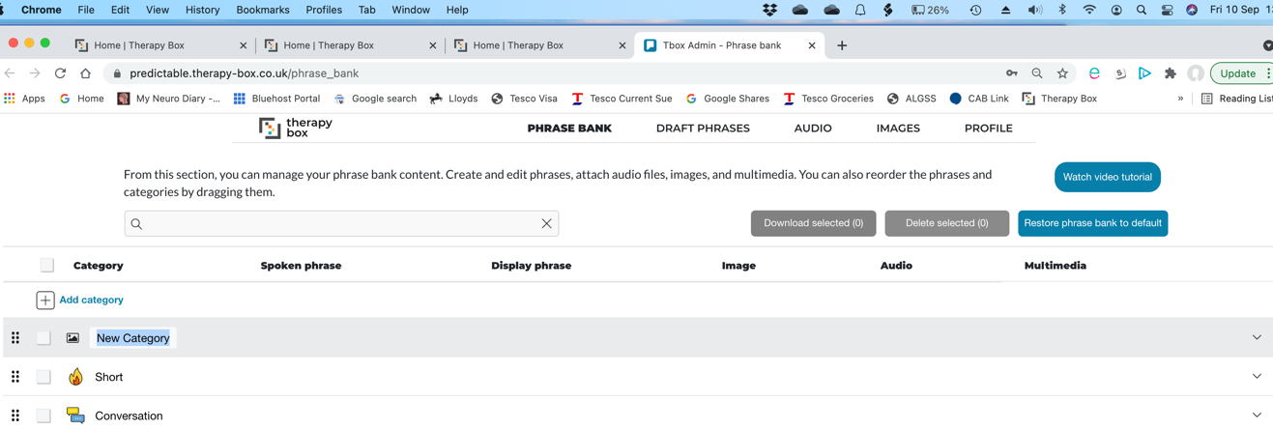

As an example, I’ve called my new category Test category. Having done this, let’s say I now want to delete it. To do that, click in the small square to the left of the category name, and then click on the red Delete selected icon:

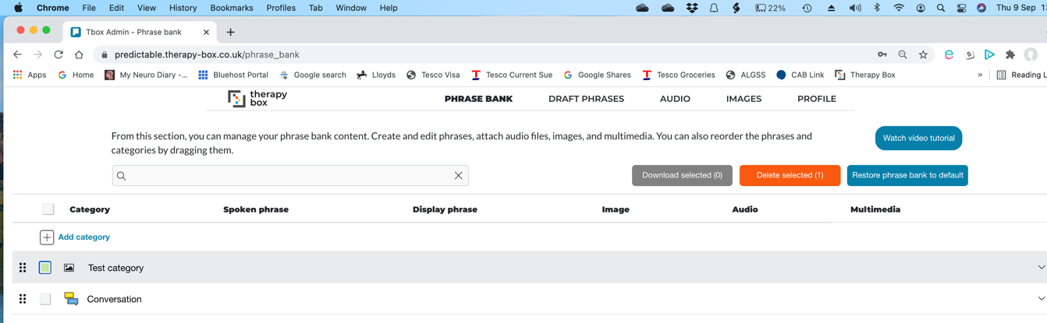

Then confirm the deletion:

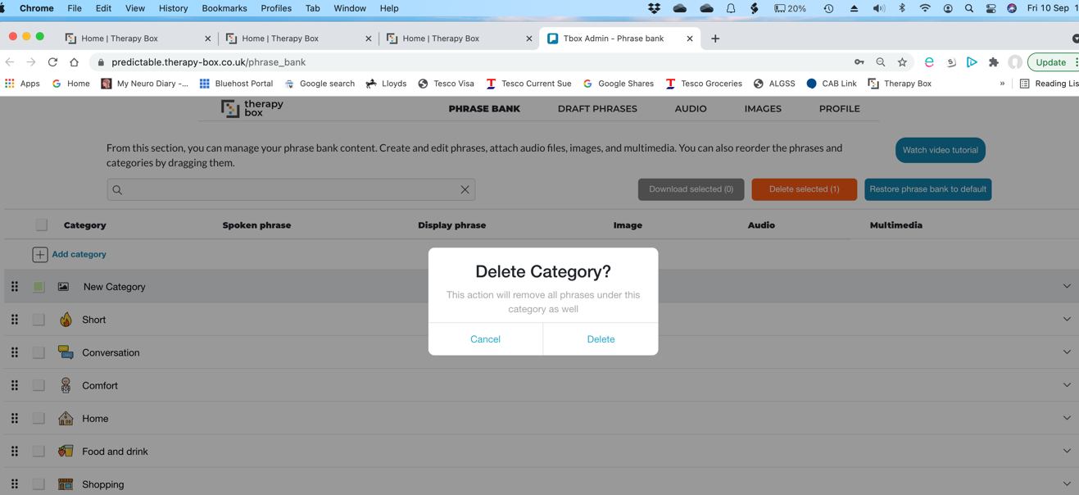

You can delete any category in the same way. But be careful. If it contains lots of phrases they’ll probably disappear too.
Managing Phrases

Click on the six black dots to the left of a category – you’ll see all the phrases within that category:

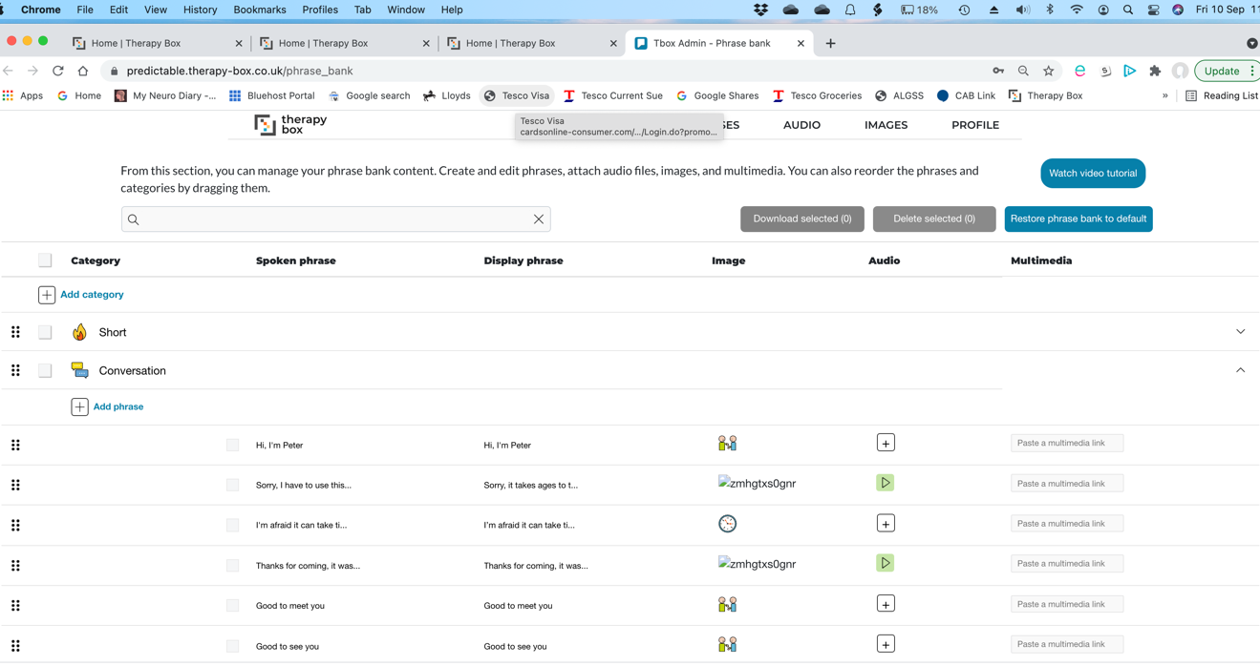

You can add a phrase within a category by clicking on Add phrase

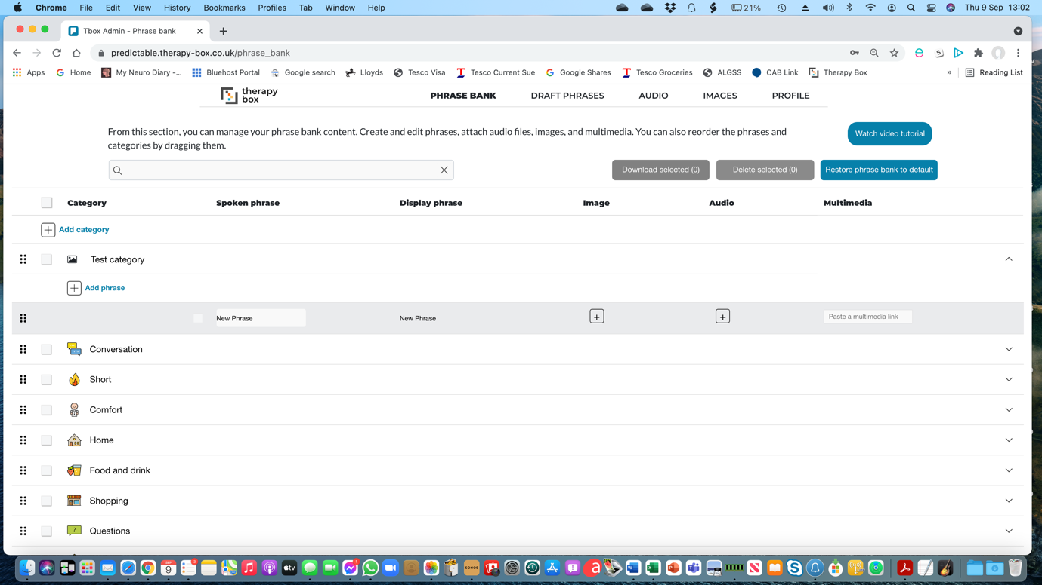

As on the iPad, you can type in the Spoken phrase that Predictable will say for you, and also the Display phrase. For example, the spoken phrase might be “Please get me a cup of tea, my dear” but the phrase displayed could be just Get Tea Now!

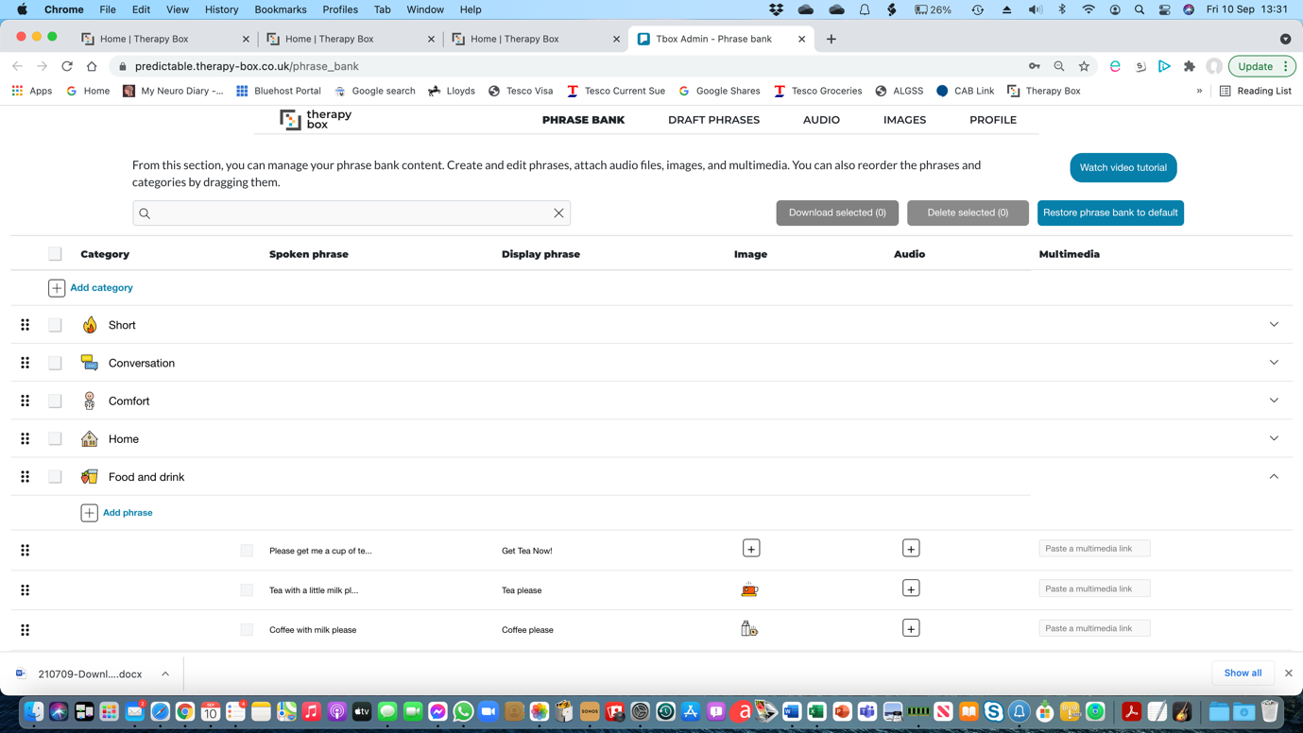

You’ll see that you can add an image (e.g. a photo on your computer of a cup of tea) by clicking on the + sign under the Image column.

You can also attach an audio file to be played instead of a spoken phrase in the same way. Before my voice faded away, on the advice of my SLT, I recorded about 25 stock phrases in my own voice as WAV files and they are now included in my Predictable library. Sadly, once your voice is on the way out, it’s too late to do this.

You can change the position of phrases within a category by clicking and dragging; the same way as you change the relative position of categories (described above).

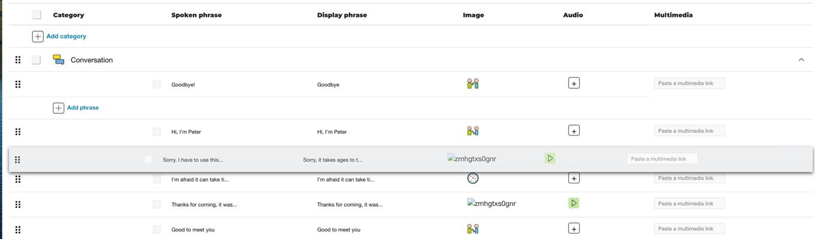

Finally, you can delete individual phrases by clicking on the small square next to the phrase, and then clicking on the red Delete selected icon.

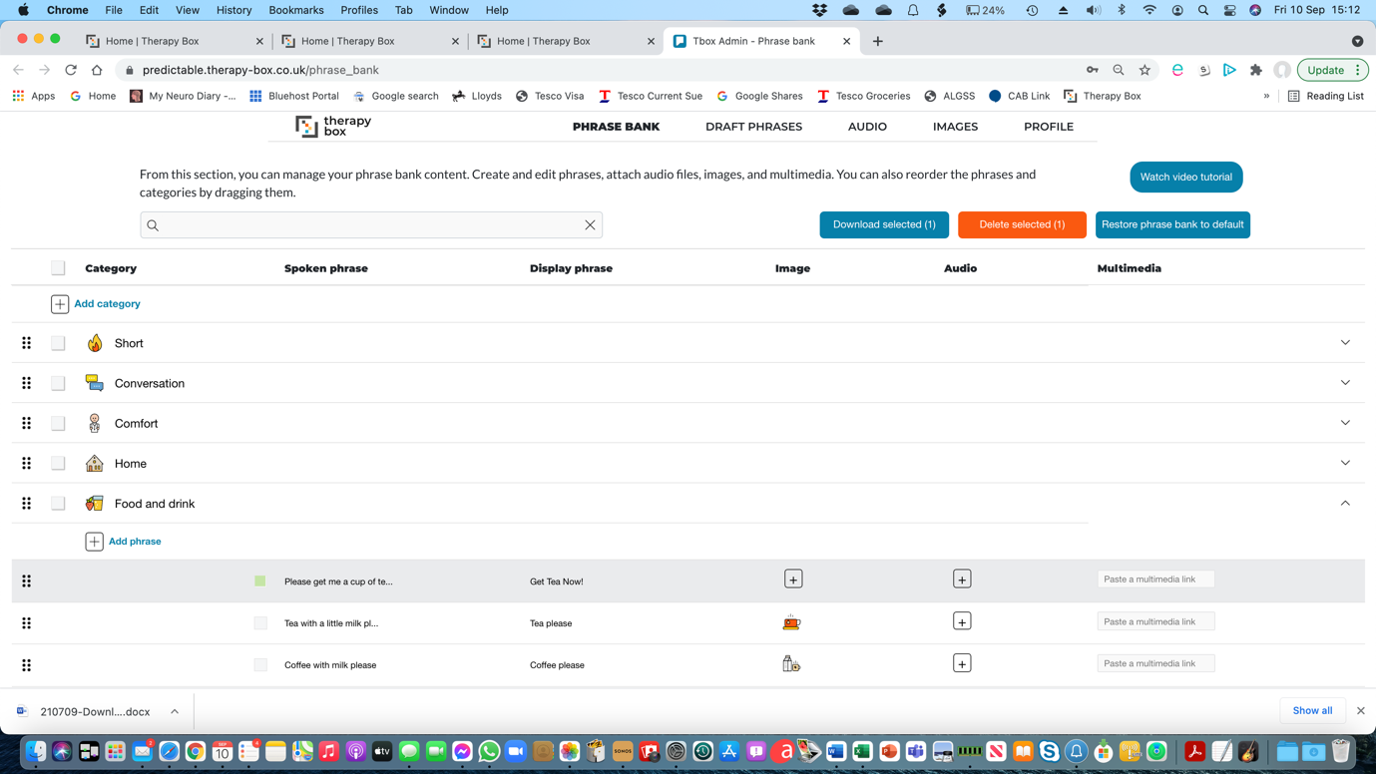

Then confirm the deletion:

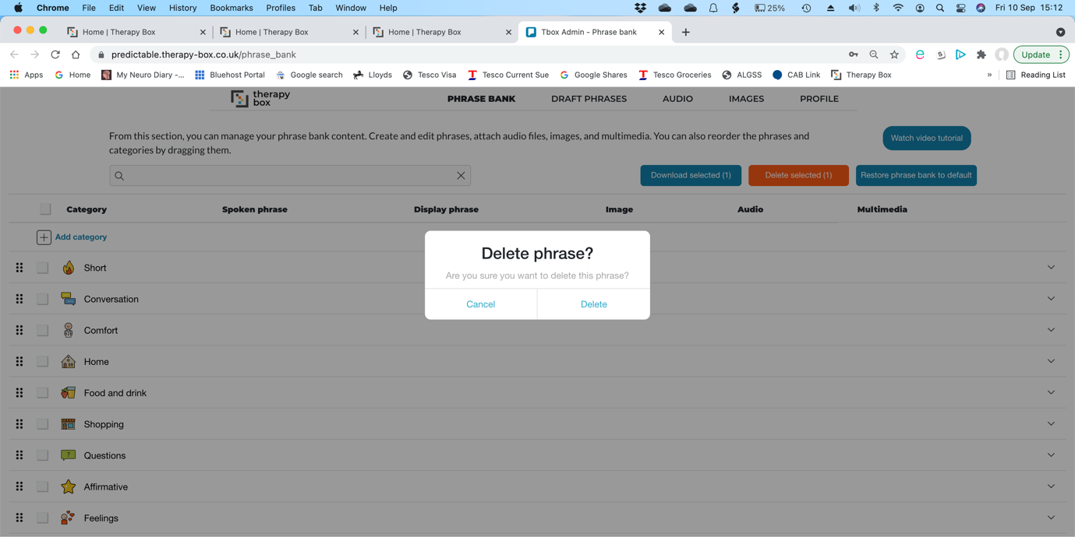

… and that’s it. Hopefully this guide will help!

